## 527/1

PRINCIPLES AND

PRACTICES OF AGRICULTURE

APRIL 2024

2 HOURS

# KABIRIZI SECONDARY SCHOOL SCHOOL

## Uganda Certificate of Lower Secondary Education

PRINCIPLES AND PRACTICES OF AGRICULTURE. SENIOR TWO

# PAPER 1.

2 HOURS

# INSTRUCTIONS TO LEARNERS:

* This paper consists of **five** items.
* Respond to **all** items in this paper.

1. When you visit a garden and look carefully at the soil, you will observe some of the different materials or components. Others cannot be easily seen. As a learner of agriculture, you might have noticed that some soils are dark coloured, likely caused by the presence of organic matter which is formed when plants and animals die and decay.



* 1. What do you think are the importance of these decayed plants and animals materials in the soil? (10 scores)

1. In Uganda, a wide variety of vegetables are grown. Some have been grown for a long time and many more have been introduced in the country in recent years. They provide both nutritional and financial benefits to humans. Study the pictures below and attempt the task that follows.

## Variety A Variety B

* 1. As an agronomist, what do you think determines the choice of a farmer in selecting a given vegetable variety to grow? (10 scores)

1. The government of Uganda is now encouraging farmers to mechanize their farming and increasingly use better tools to improve their productivity. Many organizations and businesses are busy advertising and selling farm tools to the farmers while the adverts can be colorful and misleading, farmers need to make sound decisions.

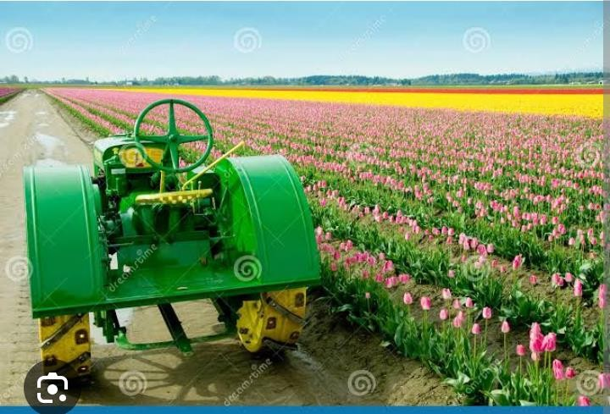

a) As an agriculture learner, what advice would you give to these farmers to ensure that they pick the correct tools to buy and use (10 scores)

(b) What advice would you give to your community to ensure that they achieve their goal of mechanizing agriculture in Uganda? (10 scores)

1. 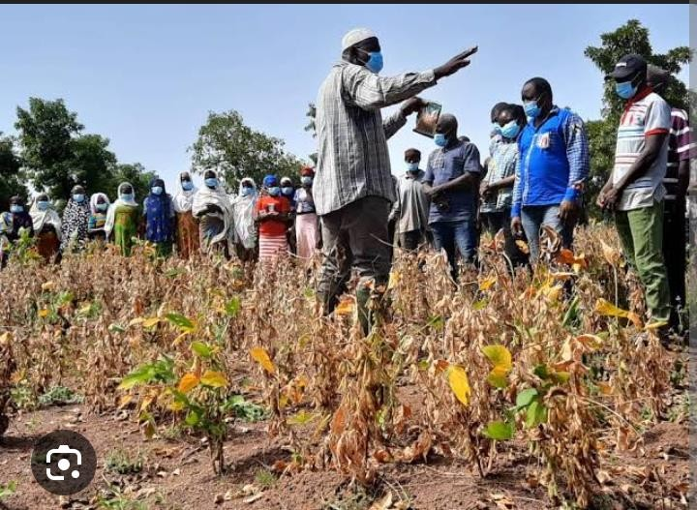In management of their farms, farmers are encouraged to keep records. In fact in some countries, farm records are a legal requirement for all farms. Many Ugandan farmers however, are not in the habit of making farm records and many do not know how to properly make these records.
2. Suggest the potential benefits of proper record keeping to the farmers in Uganda (10 scores)
3. What could be the features of a good farm record that you would encourage the farmers to keep? (10 scores)
4. In farming, farmers have to do many activities and use a variety of implements often out in the open. Accidents in such situations may occur.

As a good farmer, knowledge of the prevention of and management of certain simple accidents is necessary.

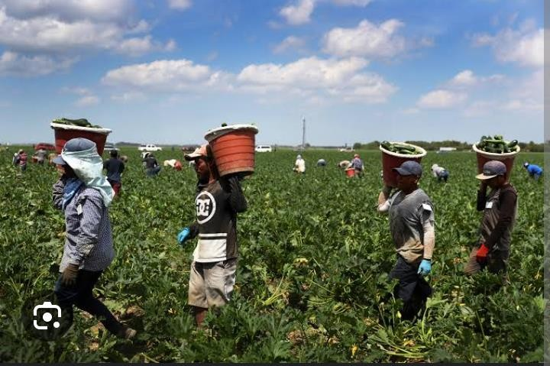

1. What advice would you offer the farming community to ensure their safety?

(10 scores)

1. What could reduce the occurrence of accidents on the farm? (10 scores)

**END**